Joseph Roper

Salford City College

BTEC National 90 Credit Diploma in Creative Media Production

Unit 69: Drawing Concept Art

Unit 69 – Drawing Concept Art for Computer Games

# Drawing with Different Mediums

Today I drew the same drawing while using different equipment such as pen, chalk and pencil. From this I found out what the best drawing medium was for me while learning the advantages and disadvantages of the other tools.

### Coloured Pencil

I found using coloured pencil quite easy although the tip of the pencil felt a lot softer than the usual graphite pencil, so it was difficult to get detail in the drawing.

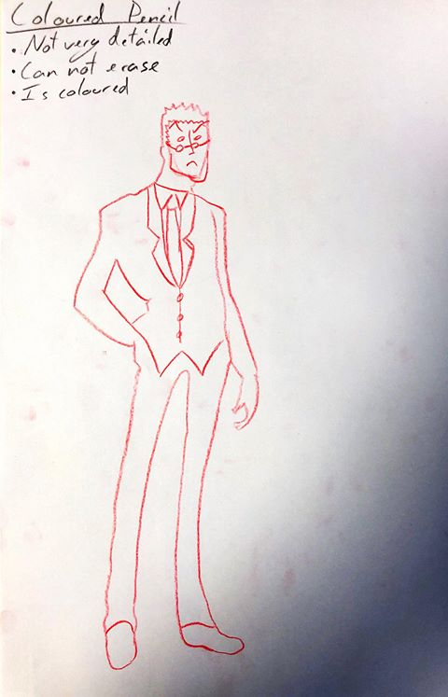

### Chalk

Using chalk proved difficult as it was very inaccurate and smudged a lot creating a messy picture.

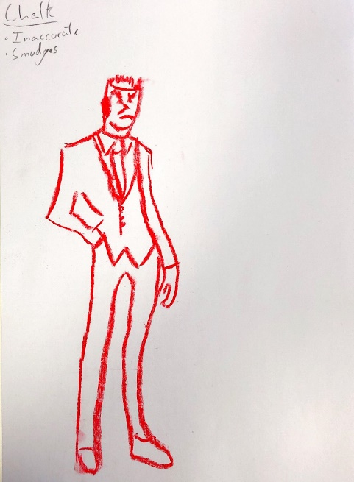

### Paint

Personally, I thought that using paint was difficult and very inaccurate as it requires experience which I don’t have to paint well. Using paint created infrequent bold and faint lines and a lack of detail.

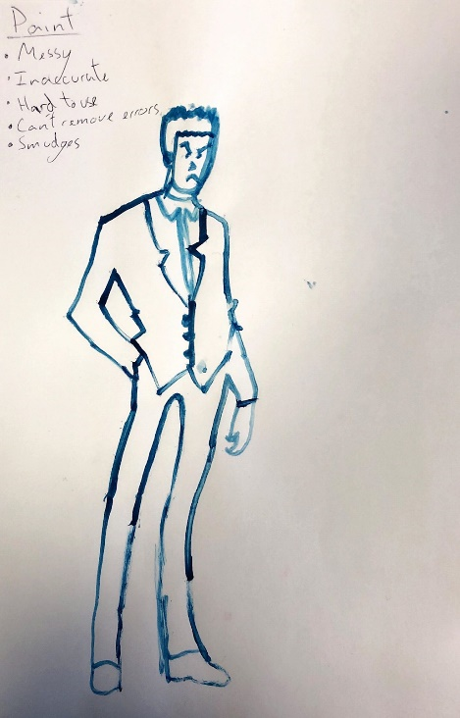

### Charcoal

I found charcoal to be really messy to use as I had to wash my hands after the drawing. However, with charcoal you can get excellent shading.

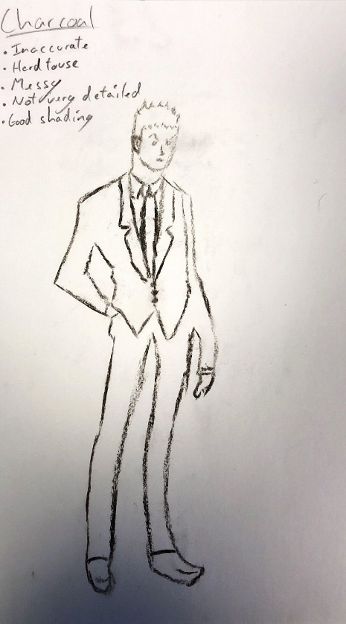

### Pencil

Pencil proved to be the best method for me to use as it was extremely accurate, easy to use and created what I believe to be my best drawing out of the others.

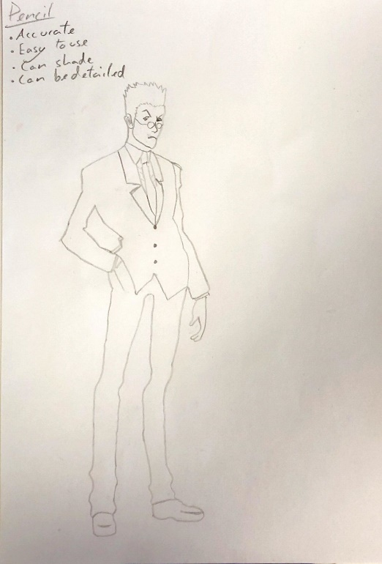

### Oil

Using oil was hard as it was inaccurate to use as I couldn’t change the thickness of my lines with it.

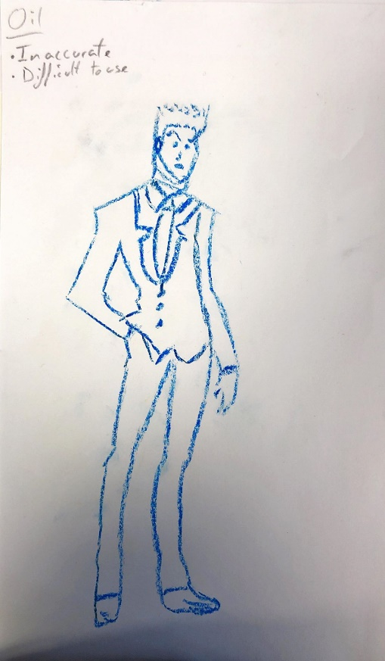

### Coloured Pen

I personally didn’t like using coloured pen as it smudged and was too thick. Although it was easy to use.

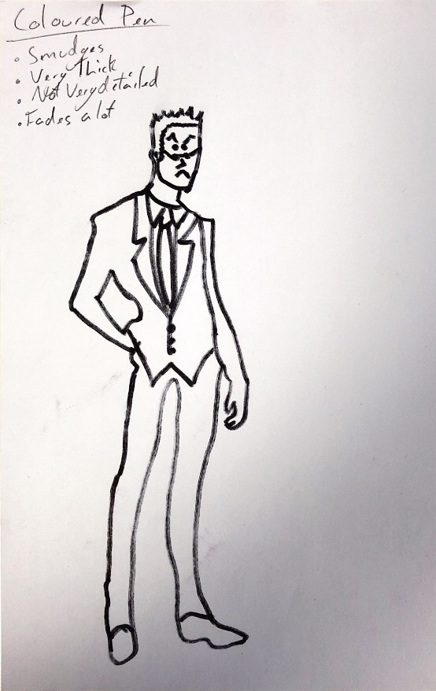

### Pen

I liked using pen as it was easy to use and accurate although it is difficult to shade with pen and you also can not erase it.

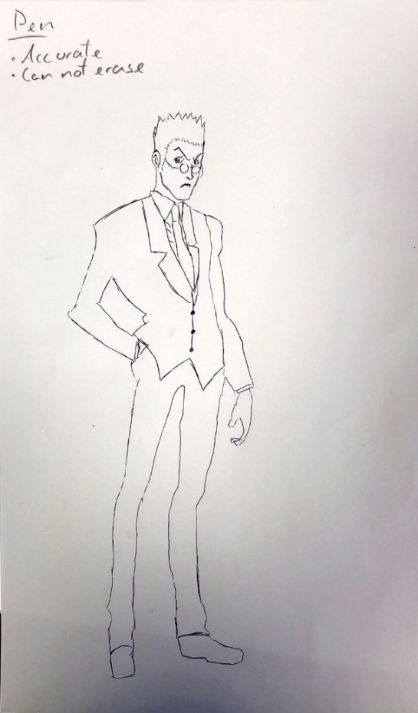

# Anatomy Drawing

Anatomy drawing is used when drawing characters, people practice figure drawing by having people make dynamic poses such as crouching and then the artist will draw what they see. The common method of drawing is the Loomis method this involves drawing a faint skeleton then drawing circles for the joints and then drawing lines from joint to joint to create the arms and legs.

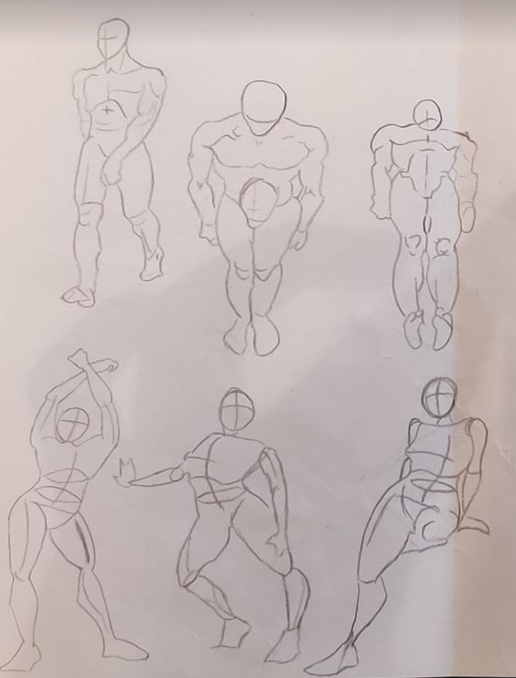

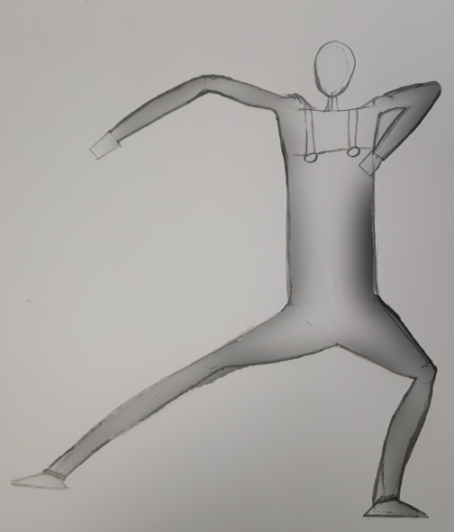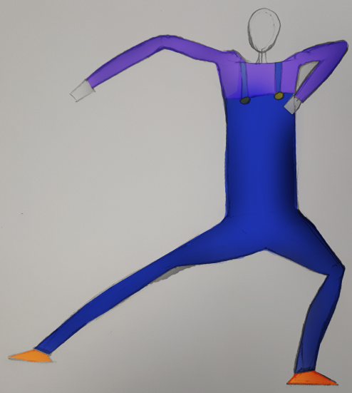

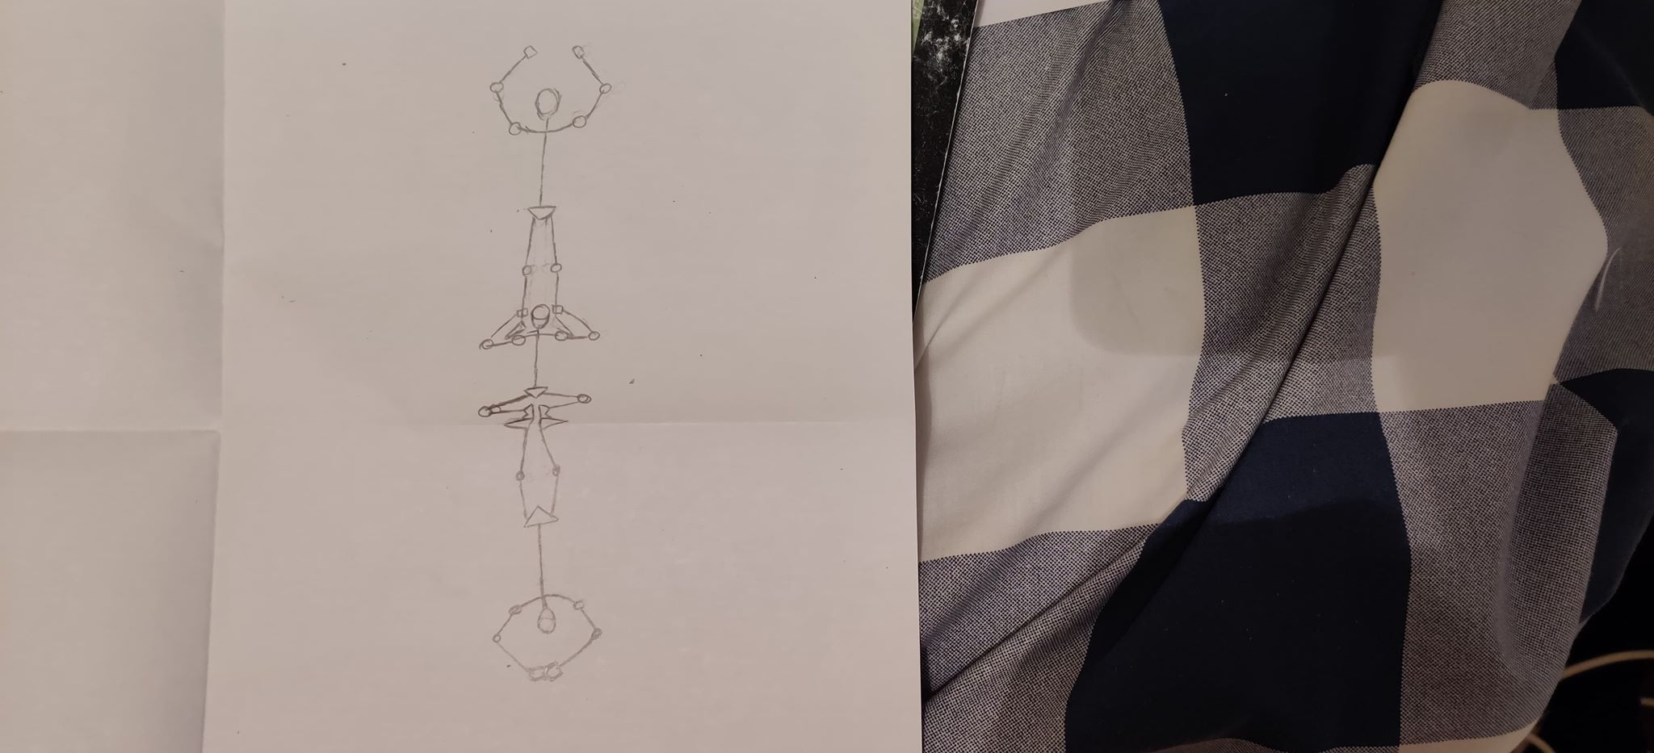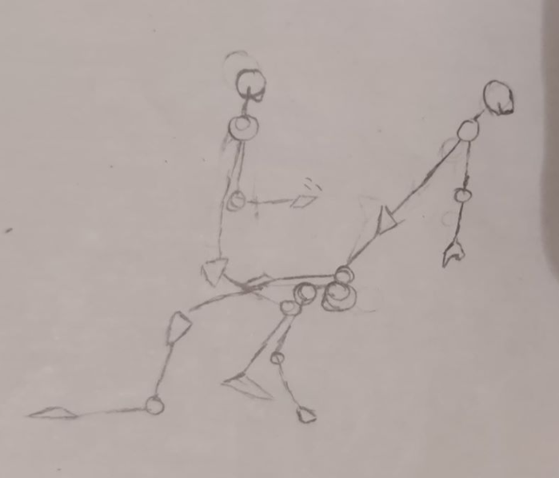

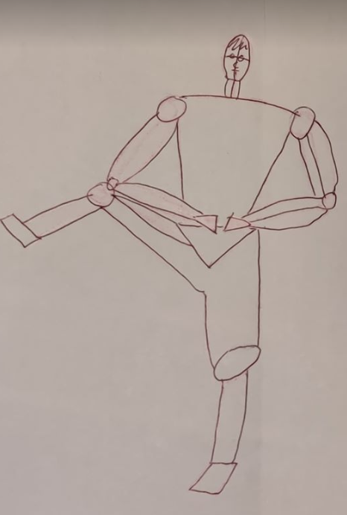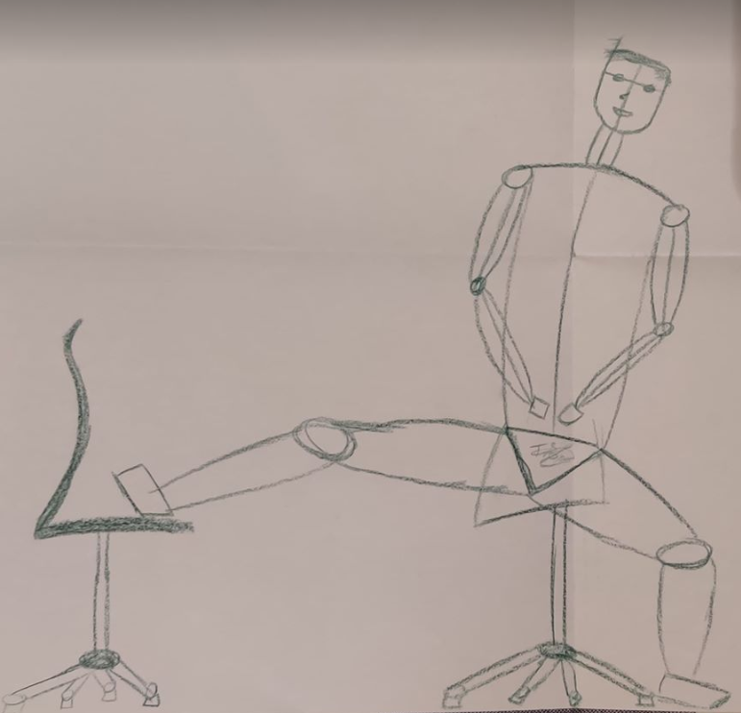

# Architectural Drawing

Architectural drawing is used for drawing and designing buildings. It involves drawing buildings from a realistic perspective and using shading to demonstrate where the light is hitting the object from. The common method used for architectural drawing is called the two-point perspective. The method is used to create the illusion of depth on a 2D sheet. The method involves the artist to first create the horizon line by drawing a straight line across the page this represents the line of sight for the viewer. Next, the artist will draw the vanishing points on either end of the horizon line this will represent the point in which the viewer will start losing sight of the building. Thirdly the artist will draw the centre line for the building as a guideline and then draw a line from each vanishing point towards the guideline at the height the artist would like the building to be, the artist will repeat this step for the bottom of the building. Next, the artist will draw a line on either end of the guideline to represent the sides of the building. The artist will then erase any excess lines leaving the cube. Finally, the artist will add windows, a door and a roof to the building using the horizon line and vanishing points to keep the perspective right.

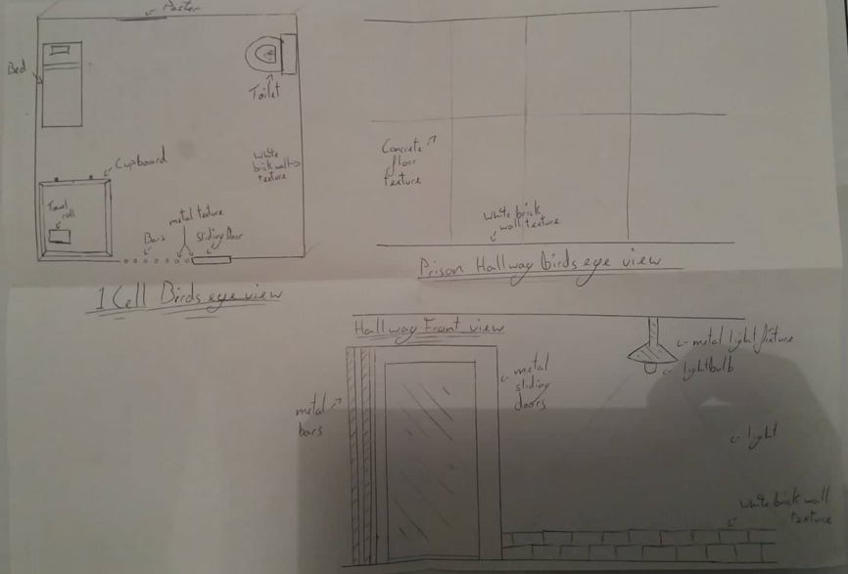

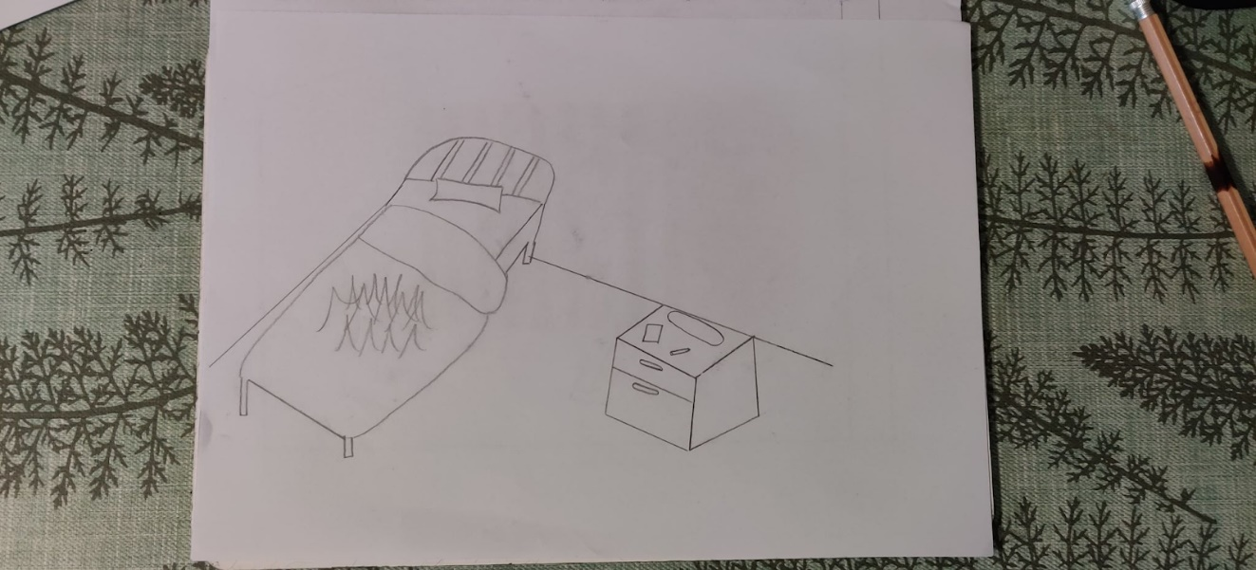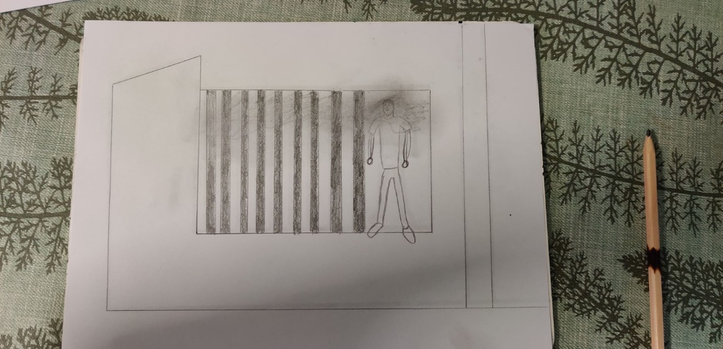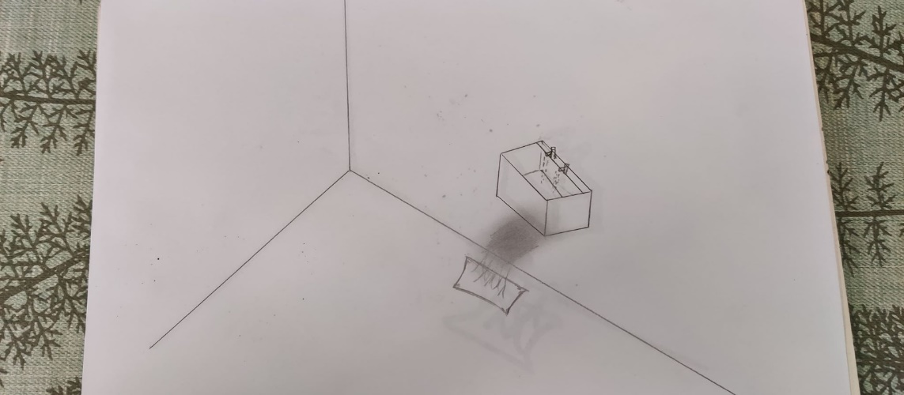

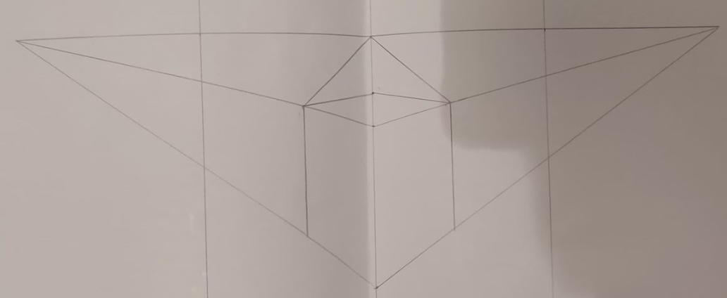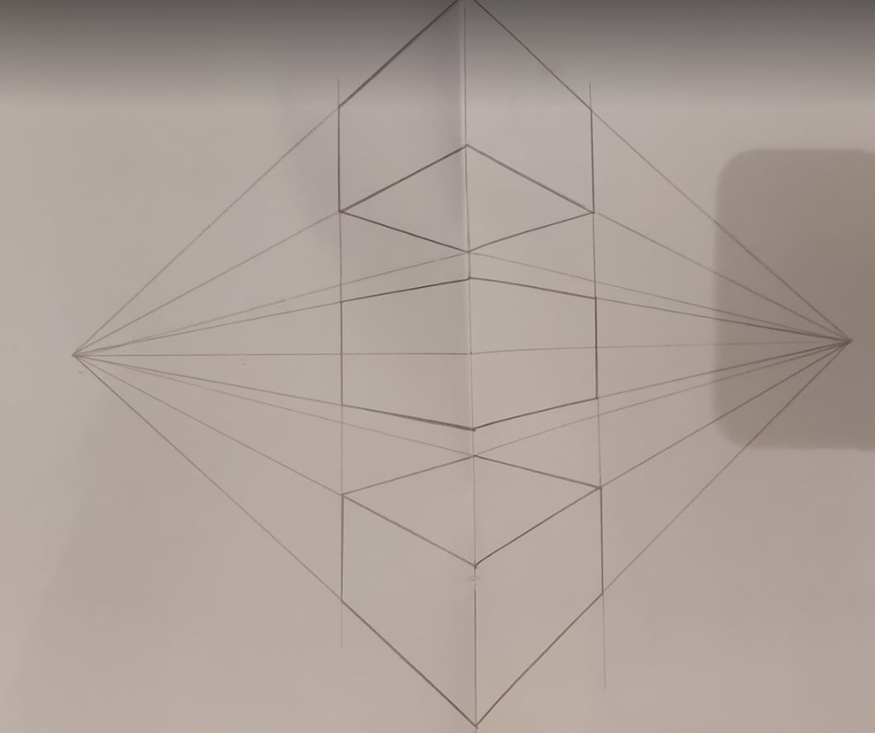

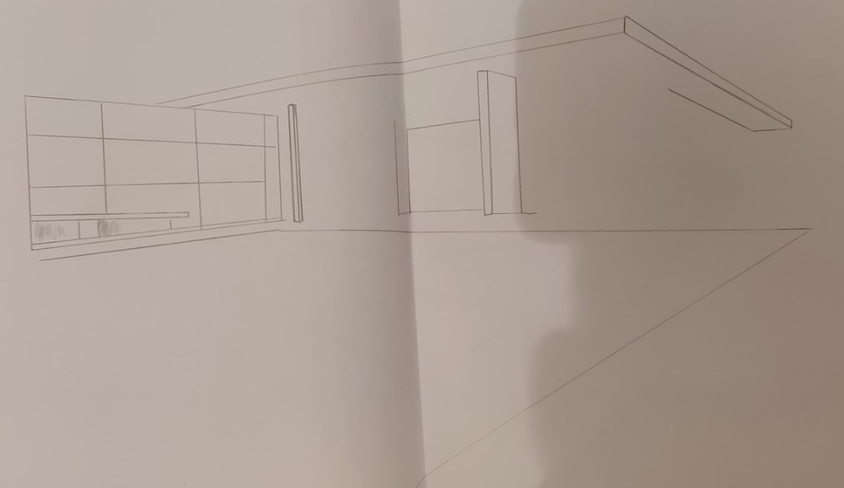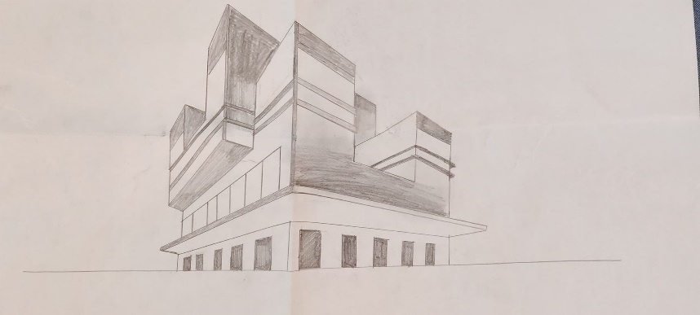

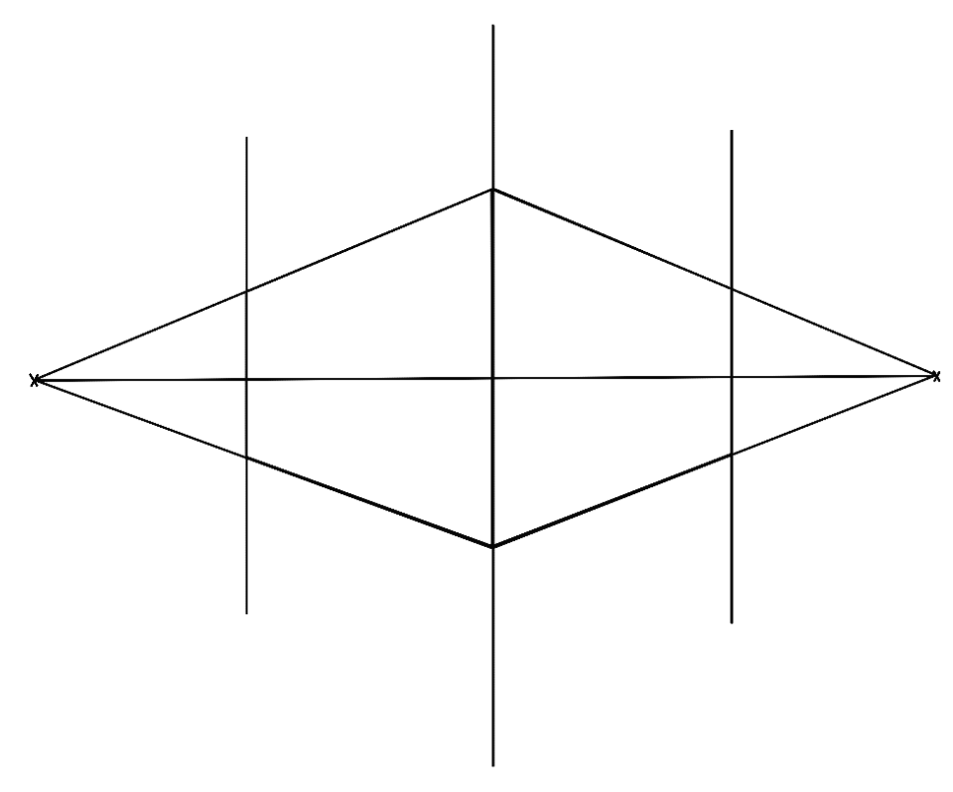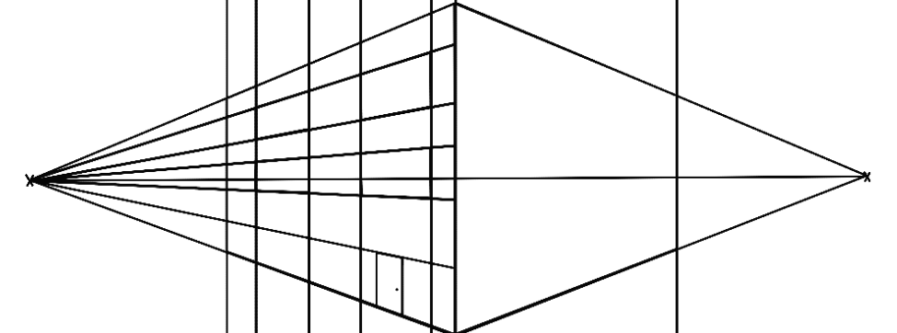

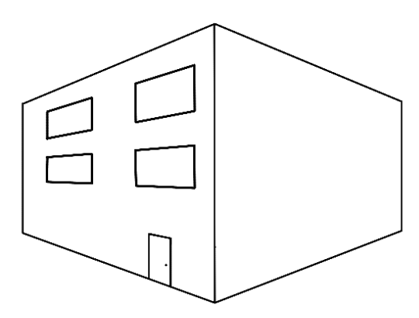

# 3D Shapes

Today I created some 3D shapes in class using Photoshop. The first object I made was the realistic sphere for this I started off by selecting my brush colour to silver/ light grey, I then enlarged my brush size and clicked my left mouse button to make the circle. Thirdly I changed the settings of my brush so that it had 50% flow and opacity. I then selected a darker grey for the brush colour and shaded in the left curve of my circle to represent a shadow. To finish off the circle I set the brush colour to a lighter grey of the original circle and coloured in the top left of the circle to represent where the light would hit the object. I then practiced this and later added a shadow underneath my sphere to make it look more realistic. I did this by creating a circle underneath my sphere and added the gaussian blur effect.

Next, I created a cylinder using the same techniques as with the sphere. Firstly, I used the marquee tool to select a rectangle and then filled that in with a grey colour. Then using the brush tool, I shaded in the left and right sides of the cylinder using a darker grey colour, then I made a streak through the centre of the cylinder using a light grey colour. I Practiced this a couple of times and then created the top and bottom of the cylinder using the same method as I did to create the spheres.

Lastly, I created a cube using the pen tool, drawing three squares with different dimensions depending of which face of the cube it was. I would then fill in the squares with colour and shade appropriately to create a sense of depth.

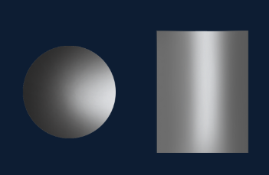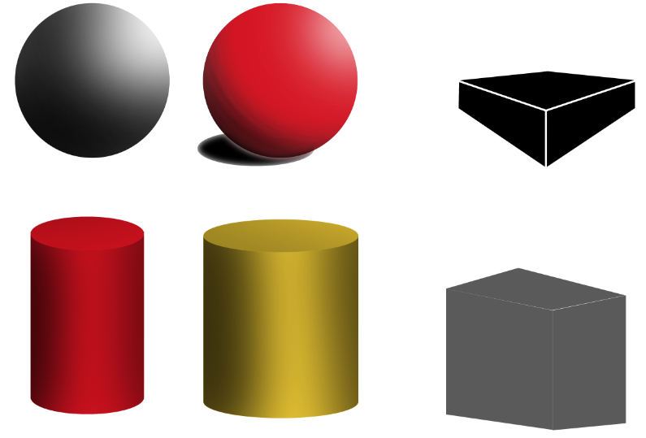 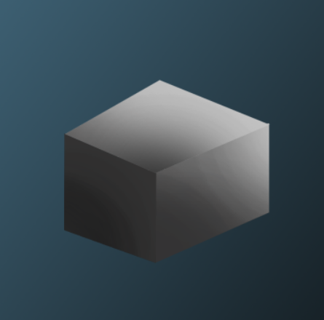

# Mood board

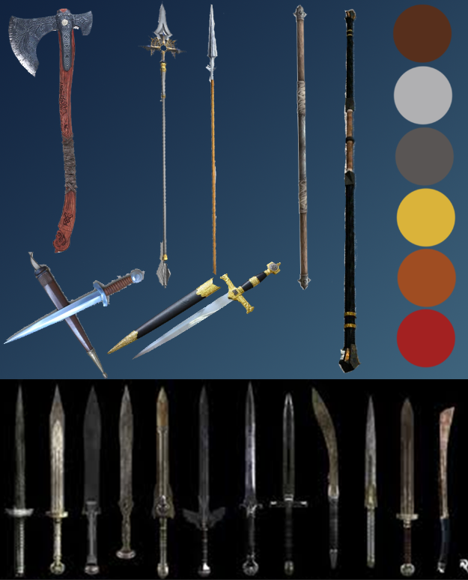

For my weapons I wanted them to be set in the medieval era but to look professionally made by an army. This is why each weapon has shiny metal, contains gold bezels and has pristine leather grips. For some of my weapons, I even added gems to make them look high-class. Each of my weapons each has a stylised look with a cartoony colour scheme which I was aiming for throughout the project. On my mood board I have made a colour scheme that I will stick with throughout my project the brown will be used for the wooden handles on my weapons, the silvers will be used to colour and shade my blades. The yellow colour will be used for the gold bezels on my weapons. The dark orange colour will be used for the leather grips on my weapons. The red

Axes used to be cheap weapons used by farmers in war so I styled mine to look like a professionally made battle axe. As inspiration, I used the axe design from the God of War game series and changed it to look like something that would be made by an imperial army, for example, changing the cloth grip to be high quality leather straps and removing the sigils to make it a clean-cut blade that would be mass produced.

For my sword designs I took reference from the swords used by DC for their popular character Wonder Woman. I used these swords as reference as I personally liked the designs of them and they also fit in the theme I had for my weapon designs which is a cartoon medieval weapon design. And since wonder woman was originally a well-known comic book character it fits with the public's perception of cartoony medieval weapon designs.

For my staff designs I took reference from the quarterstaffs used in the medieval era but made them look more high class by adding leather straps, varnished wood and gold-plated bezels to make it look like a weapon that would be used by an imperial army.

For my spear and dagger, I didn’t have a direct reference in my head that I could use to inspire me for my weapon. So, I just ended up searching spear and dagger medieval designs on google and placed a few of the images into my mood board so that when designing the weapons, I had some reference of the overall shape of the weapon.

# Weapon Concept Art

For my suite of weapons, I decided on creating a Sword, Spear, Axe, Dagger and Staff for each of these weapons I will rapidly prototype different ideas on either paper with a pencil or photoshop using the brush tool. With every new drawing of a weapon I will implement a new idea and build upon that in the next drawings. I decided to make the first suite of weapons on paper but then for the others I decided to use photoshop as I will be using the program to make my final designs anyway, to save time and quality I decided on strictly using Photoshop to make my weapon ideas and final designs. Advantages of using photoshop are hat I can copy and paste my previous drawing and add on it more easily. I can also copy and paste half of my drawing and then flip it to keep symmetry within my drawings. Another useful addon is that I can create perfectly straight lines by holding the shift key while using the brush tool.

## Sword

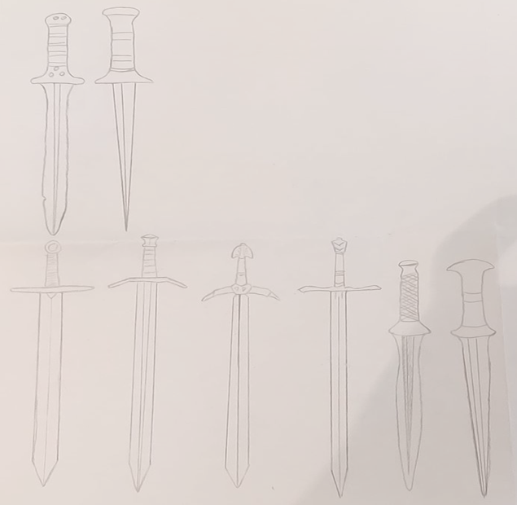

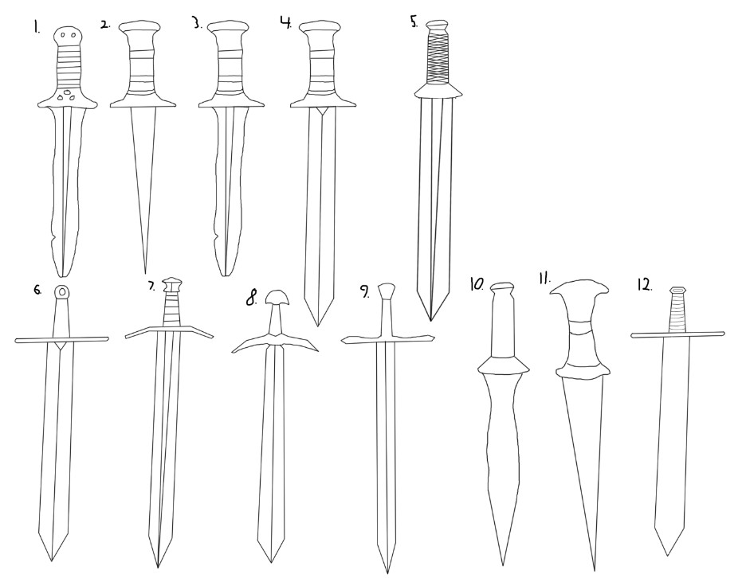

For my first design I drew a battle-scarred sword with gems and old well-worn leather. For the 2nd design I went for a blade with more of a point but roughly kept the handle the same but just removed the gems. With my 3rd design I took the blade from the first weapon and the handle from design 2 and combined them to see how it would look however I decided to make a new blade in design 4 making it look heavier and sturdier. For design 5 I kept the large blade and added a different handle with a grip. For design 6 I changed the handle to make it look slimmer and added a larger guard. For design 7 I changed the guard design to make it less straight. For design 8 I changed the handle and blade design however I though this drawing didn't fit the theme and looked too flimsy. With design 9 I went back to a straight guard and added a gem on the end of the handle. For design 10 I went back to the handle used in design 5 and added a curved blade however this didn't look professionally made. For design 10 I made a similar handle used in design 2 and added a bigger blade however for my final design I drew a handle with a leather grip with a gem attached onto the end of the handle. I then added a straight guard and a large sturdy blade. I chose this as my final design as I believe it looked the best out of my drawings and with the colour scheme used in my mood board would look high class.

## Spear

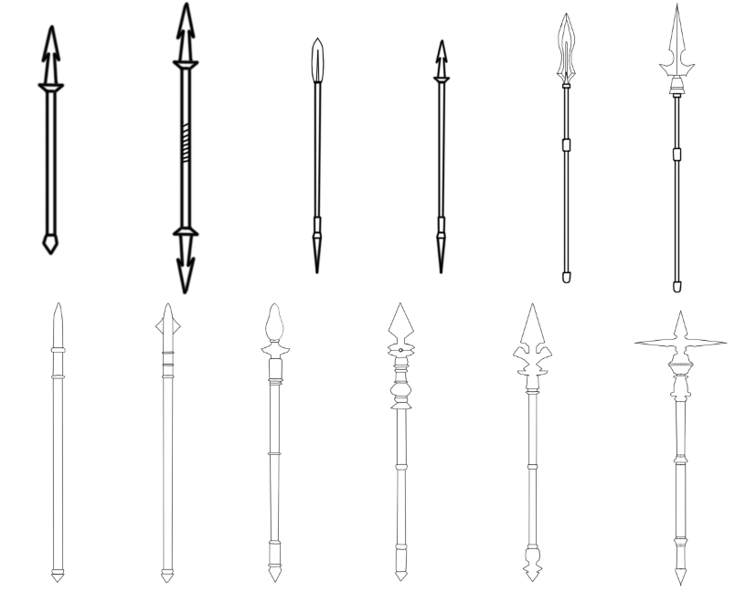

For my first spear design I took reference from my mood board and drew something similar however I added jagged spikes on the spearhead. Following onto design 2 I took the spear head and added on both ends of the shaft. I also added a leather grip in the centre of the spear. For my 3rd design I changed the spear head design to make it more curved and added a spike on the other end of the spear. For the 4th design I used the same shaft as the previous design but tried it with the jagged spear head. For my 5 the design I changed the design of the spear head again making it more curved and added more metal in the centre of the spear head to make it look sturdier. For design 6 I changed the spear head design however I didn't like this one as it seemed the design would be too flimsy for real combat. For design 7 I started from scratch and went for a more simplistic approach with just a pointy metal rod taking reference from fishing pikes…. In the eight design I added spikes on the sides of the spear head and changed the design of the shaft to have more bezels. For the 9 the design I changed the head of the spear design however I felt that it looked too round to do piercing damage. For the 10 design I tried adding more decoration onto the shaft however I thought this made the spear look too cluttered. For my 11 design I changed the spear head and spear end design however I again thought this looked to flimsy for battle. For the final design I changed the spear head but I believed it looked too big and heavy for real combat. The design I chose to be my final weapon design was drawing 5 as I believed it looked high class and something that would be used by an imperial army.

## Axe

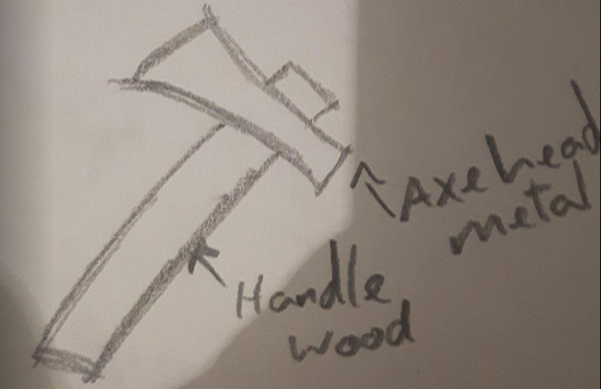

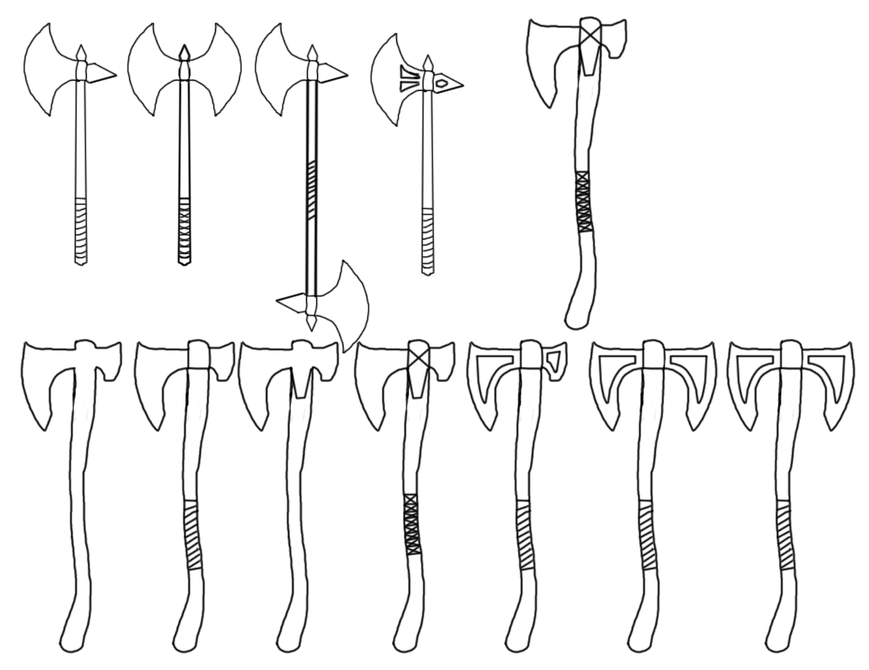

For the first design, I just drew a simple axe design as a reference and then would start changing it from there. For the 2nd and 3rd design, I tried adding multiple axe heads to see how it would look however I didn't think it would fit my theme of mass-produced weapons as the design in real life would be too heavy and expensive to make. For my 4th design, I decided to make the axe head have holes but I didn't like this design choice as it would make the weapon look flimsy in my eyes. The 5th design is just a copy of the final design I went with, design 10. For the 6th weapon, I decided to change the axe head and shaft of it from a straight piece of wood to a thicker, sturdier piece. For my 7th design, I added cloth wrapped around the shaft to act as a grip improving on the previous drawing. For my 8th design, I added to the head of the axe to have more metal. For my 9th design, I made the addition to the head on design 8 a separate piece to make it look tougher. For my 10th design, I added holes into the axe head again but I still didn't really like the look of the weapon. For the 11th and 12th design, I tried adding more axe heads but I still did not like the design choice. For my final design, I chose drawing 9 as I felt it fir the theme I was trying to aim for more than the others.

## Dagger

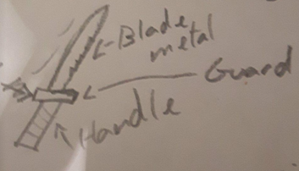

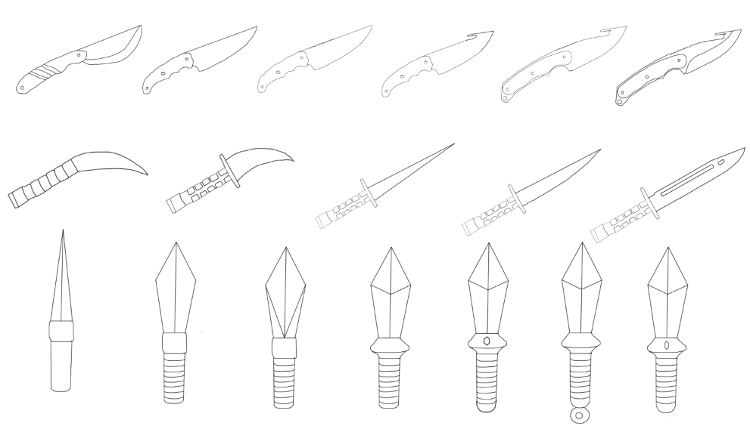

For my first knife a drew what I had in my mind as a standard knife. For the second and third design I changed up the blade and handle to look less rugged and more well-built. For the 4th design I added a pip on the blade to represent the style of a gut knife. For the 5ty design I made it so the whole knife was metal with wood screwed in on top to represent the handles I did this to make the knife look sturdier I also made the pip on the blade bigger. For the final gut knife design, I cleaned up the drawing to make the lines thicker and straighter and then added an edge on the blade to make it look sharper.

For the 7th design I tried something different and changed up the handle design to look more professional. For the 8th design I made the blade more curved but I decided I didn't like this look I also added onto the handle to make it personally look better. For design 9, 10 and 11 I changed up the blade to be straighter and longer.

However, for my final set of dagger designs I desired to go back to the medieval theme I was aiming for in my mood board. For design 12 I drew off my head what I though a dagger would look like and then started changing it to look more appealing. For design 13 I added leather straps onto the dagger and changed the blade to look sturdier. For design 14 o tried changing the design of the blade but I didn't like this idea do I quickly moved onto design 15 where I changed the blade design to the final one and then added a hilt onto the dagger. For design 16 I added a bump on the end of the handle and added a gem in the middle of the hilt. For design 17 I tried adding onto the end of the handle but I didn't like this idea so for my final design I got removed the change and cleaned up the gem design.

## Staff

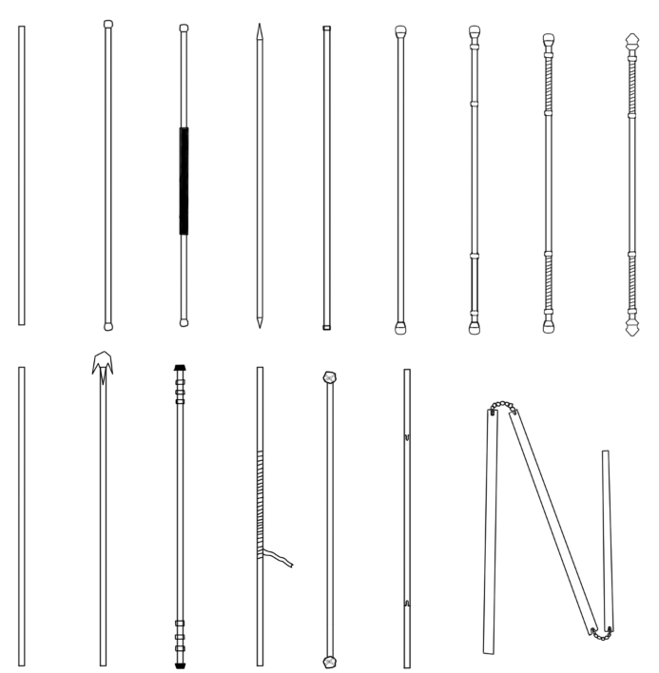

For my first staff design I drew a simple long and straight piece of wood and then added onto it in the next designs. For my 2nd design I added metal caps on the end of the staff to be used for blunt force. Then in design 3 I added a grip in the centre of the staff. On the 4th design I added spikes on each end of the staff to see if I would want a staff used for blunt force or a design more suited to piercing damage I ended up deciding on a mixture of both. For design 5 I changed the design of the caps however this would be quickly changed in design 6. For design 7 I added metal bezels going along the staff so that it could be swung sideways and stiff give out damage. In design 8 I added grips in-between the bevels. For design 9 a changed the end of the caps to have more of a point. For design 10 I started from scratch again with a basic staff. In design 11 I added spikes onto the cap of the staff but I didn't like this design choice. For drawing 12 I added more bezels onto the staff. On design 13 I made it so the staff had a more rural Japan vibe with the long flowing cloth on the staff however this didn't fit my theme so I scrapped it. For design 14 I added rocks on the end of the staff but this looked to barbaric for what I had in mind as my final piece. For design 15 and 16 I drew an interlocking system that split the staff into 3 parts however this was what I believed as too futuristic for my theme. The design I will use for my final piece is drawing 9 as I believe it fits the theme as it is the most uniform and going off of the colour scheme used in my mood board it will look high class.

# Final Weapon Concept Art

To make the final designs of my weapons I would pick the drawing of the weapon I liked most from my suite of weapons and then copy and paste it into a new file I would then outline specific parts of the drawing such as the hilt, blade and handle using the pen tool and then saving each outline as a new path. I would then go to each path such as the handle path and fill it in using my colour of choice and then on a new layer I would shade in the handle to add depth to the object.

For the blades, guards and gems in my final designs I would first make the outline using the pen tool fill it in with the colour of choice and then use the bevel & emboss tool in photoshop which allowed me to control the depth, size and softness of my bevel. To finish of the bevel, I would then shade the inside and outside of the bevel separately tom make it more realistic.

To create the grips used on my weapons I created multiple rectangles stacked on top of each other, coloured and shaded them separately outlined them and then added a blur effect. I then placed the grip over my handle pressed CTRL + T, right clicked the object and selected warp and then adjusted the image to fit the handle to create the illusion of the leather grip to be wrapped around the handle.

For each weapon I added a blur effect to make the drawing pop out. To do this I used the brush tool selected the colour black and outlined the weapon I then navigated my mouse to filter then down to blur and selected gaussian blur and tinkered with the settings until it looked good.

To finish off each final weapon design I added a background colour that complimented the drawing I did this by selecting a light blue and dark blue colour. Then using the gradient tool, I dragged my mouse from either corner of my screen to create a good-looking gradient effect behind my piece.

What I found useful while creating my final pieces was naming my layers accordingly and grouping them together to create a clean and helpful filing system. This sped up my workflow exceptionally as I knew what each layer was, so I didn’t have to spend time searching for the right one.

## Background

To make the background for my weapons I started off by making a gradient of dark blue to light blue going from the top left of the picture to the bottom left. I chose these colours as I thought they contrasted well with the colours used for my weapon designs. I then using the marque tool selected a rectangle shape going through my weapon and added the gradient effect to the selection. Thirdly I acquired a picture of a cloud from the internet pasted it into the same selection as the previous gradient however on a new layer. I then overlaid the image and changed the opacity of the image to about 30. This added depth to my background. Using the same selection on a new layer I filled it in black and went to filter, blur and then gaussian blur. Finally, I created a new layer with the same selection and then went to edit and stroke. I then made the stroke size 3 pixels and changed the colour of it to light blue and selected ok. This created a nice border around my background and with that my background was finished. I believe this background is great as the colours contrast with my weapons making them individually stand out, and the depth effect using the clouds makes my weapons pop as well.

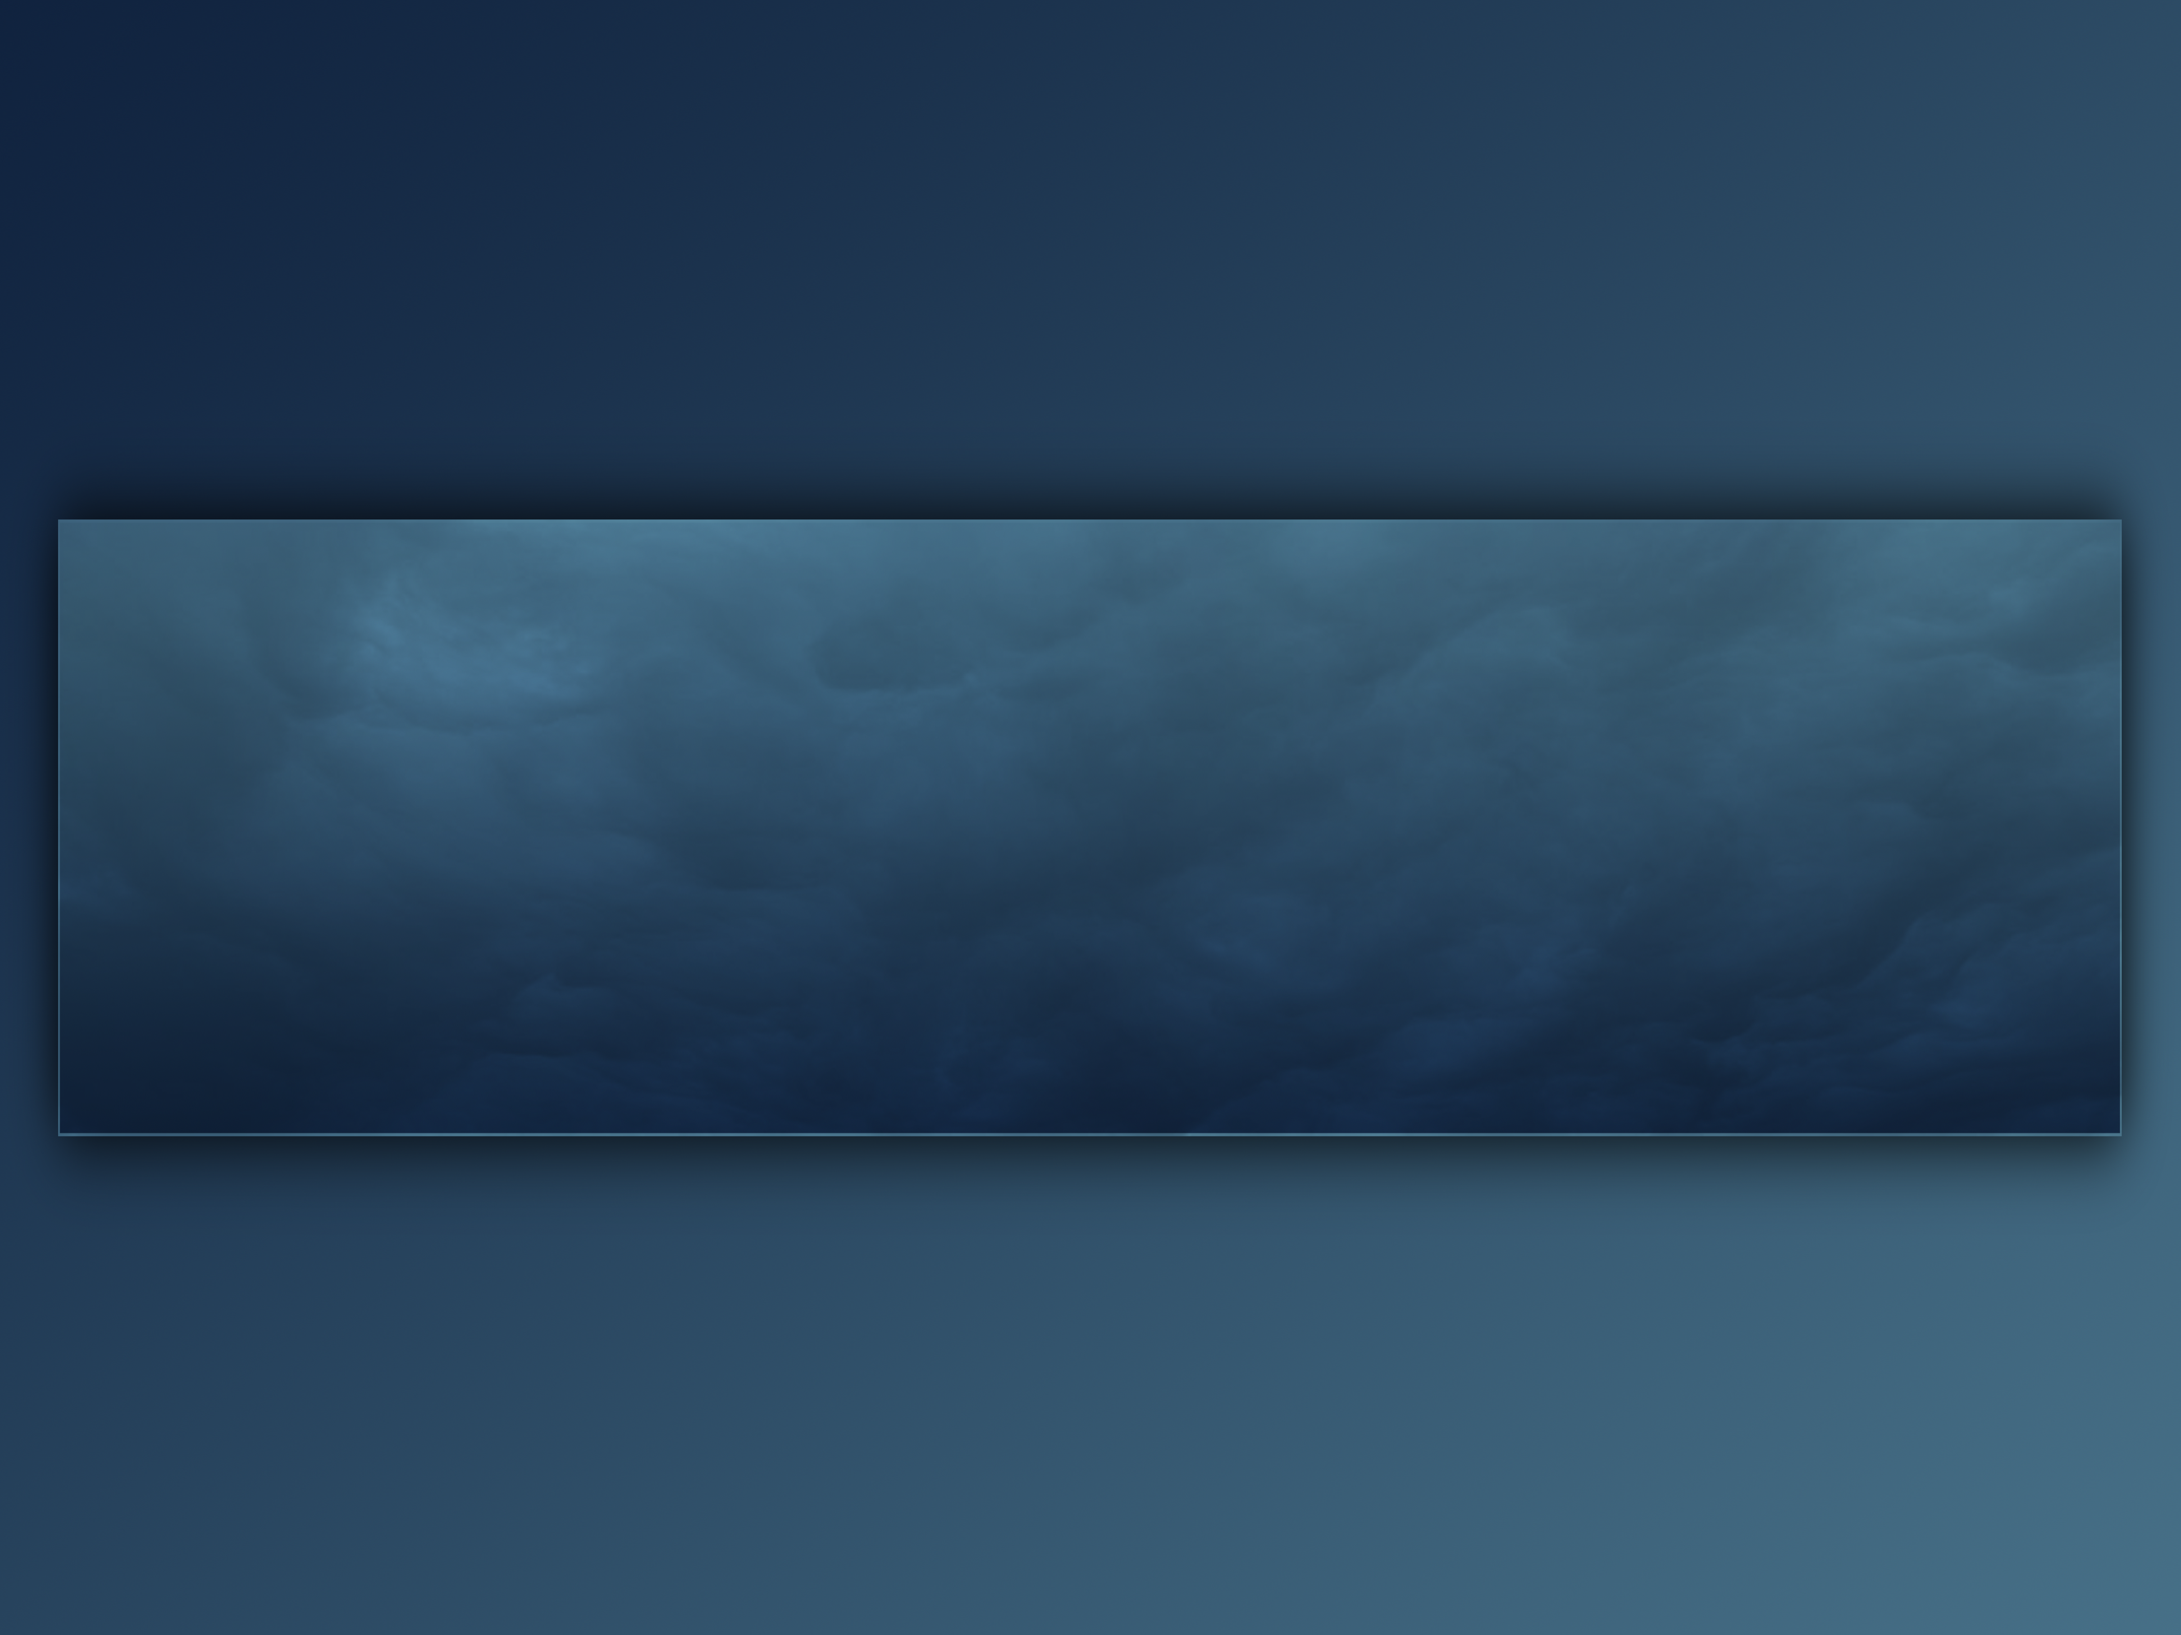

## Sword

For the final sword I tweaked my earlier version by realigning the blade with the handle and then I lightened up the shading so the blade didn’t blend into the background. Finally, I placed the weapon on my new background in the centre to make it stand out to the viewer.

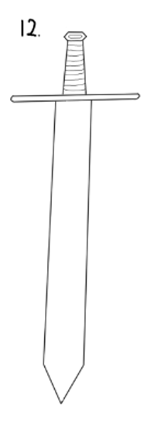 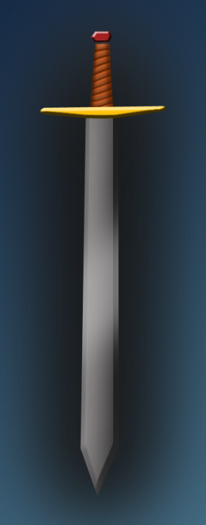

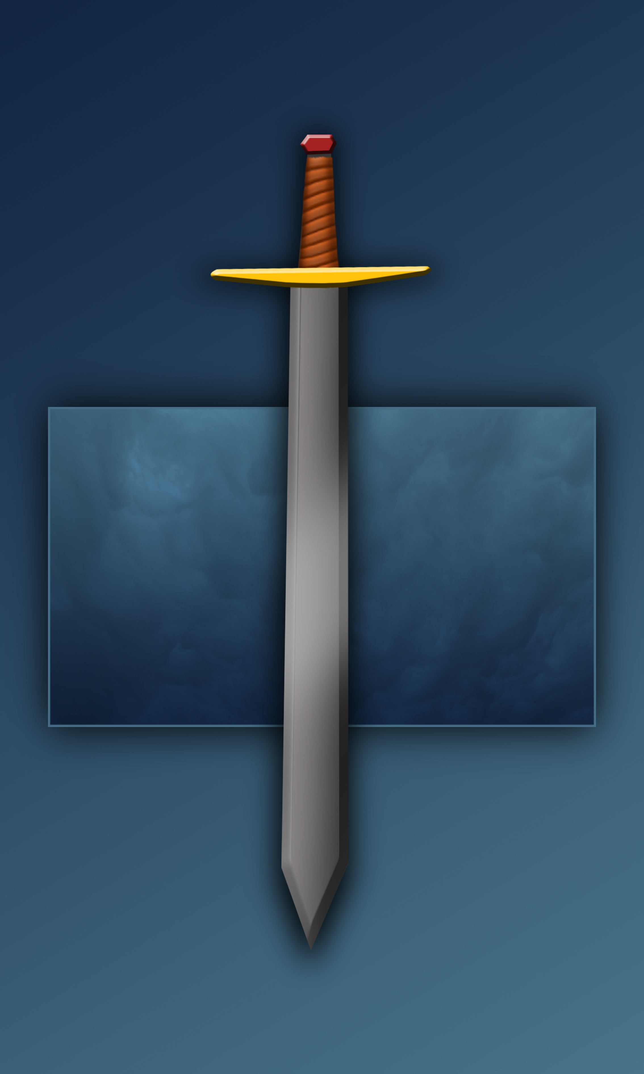

## Spear

For the final spear I tweaked my earlier version by adding leather straps and another gold bezel. I then changed the sizes of the bezels to make the spear have better proportions for actual combat. Finally, I placed the weapon on my new background in the centre to make it stand out to the viewer.

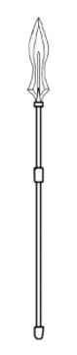 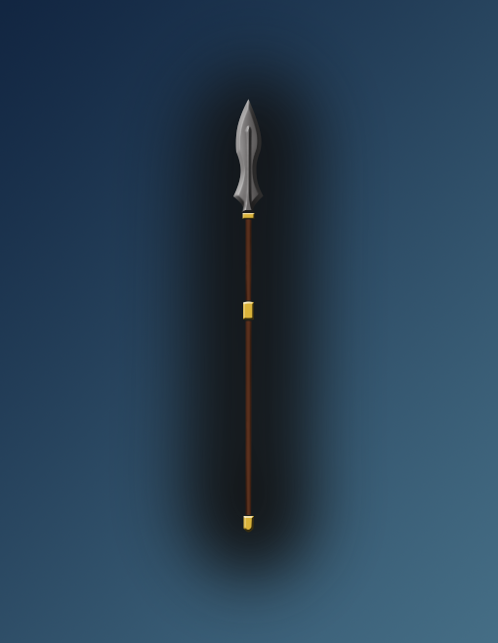

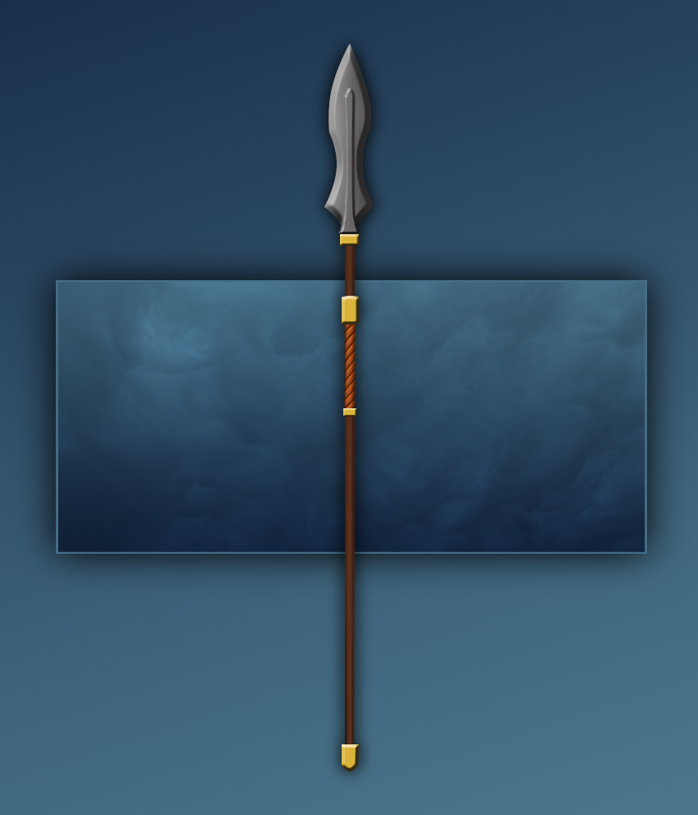

## Axe

For the final axe I tweaked my earlier version by adding leather straps and gold bezels to make the axe look more high class and match my other weapons following the same theme. I then redid the shading of the wooden body of the axe to add more depth. Finally, I placed the weapon on my new background in the centre to make it stand out to the viewer.

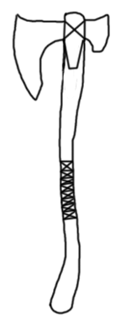 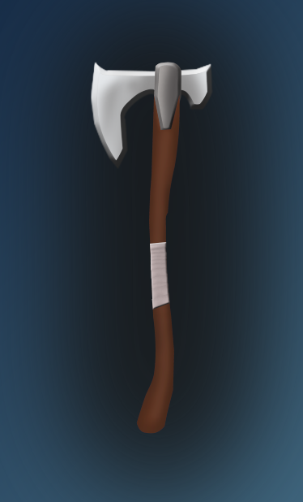

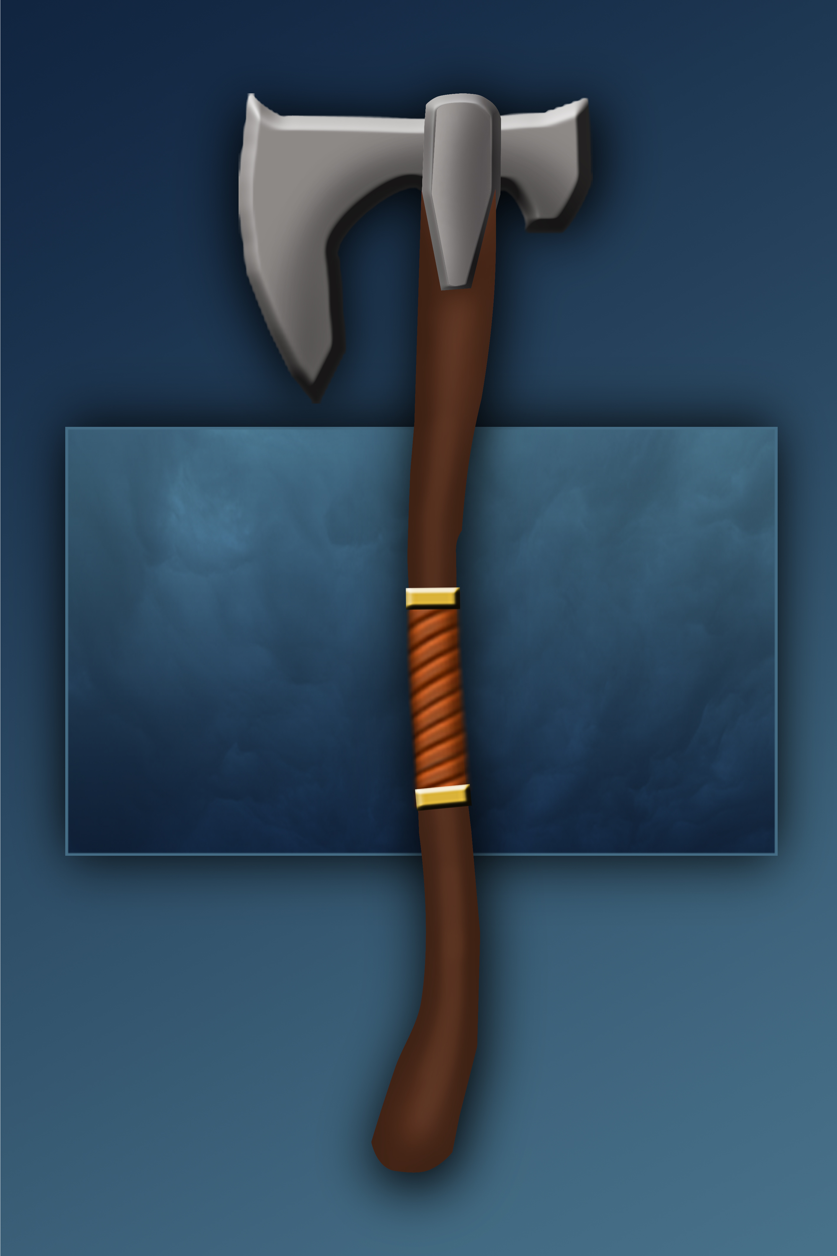

## Dagger

For the final dagger I tweaked my earlier version by aligning the leather straps so that they looked more uniform making it look more high class, matching my other weapons following the same theme. I also lightened up the shading so the blade didn’t blend into the background. Finally, I placed the weapon on my new background in the centre to make it stand out to the viewer.

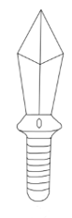 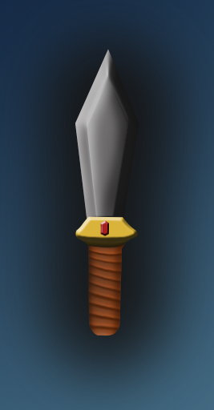

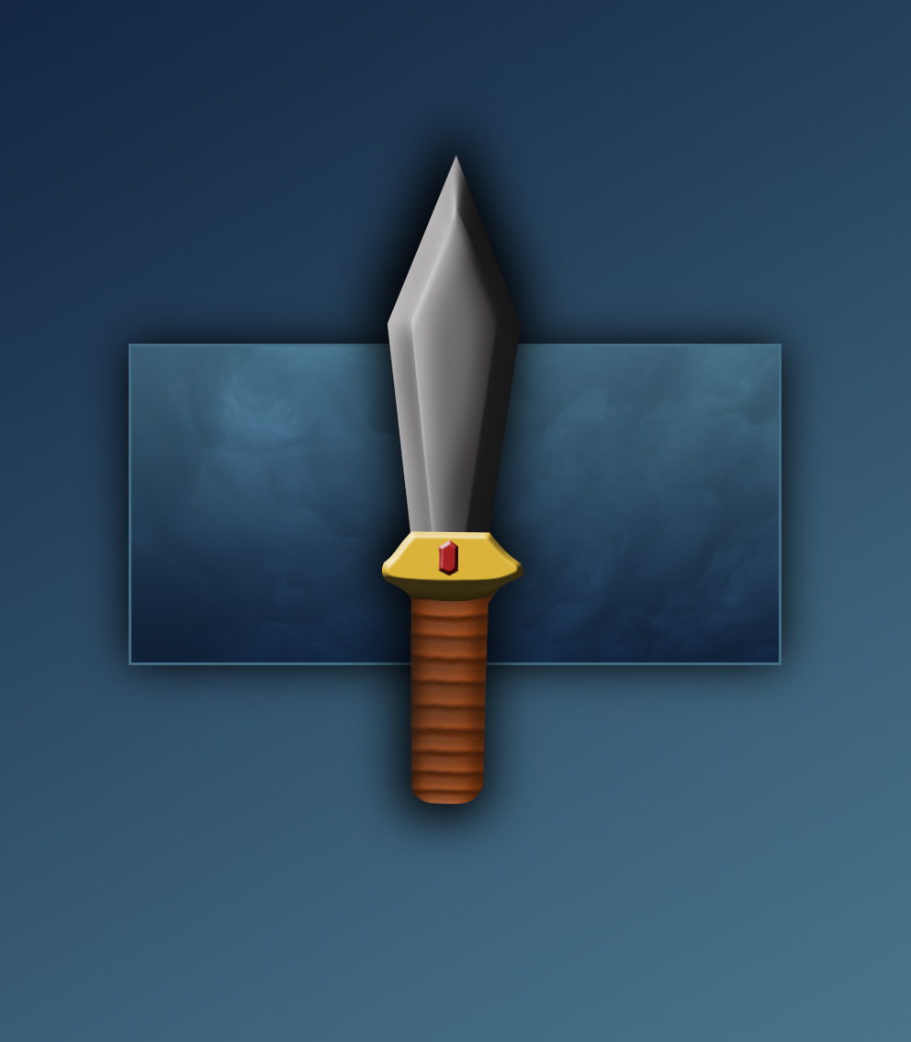

## Staff

For my final staff design I placed the weapon on my new background in the centre to make it stand out to the viewer. I also did this so that my weapon matched my others.

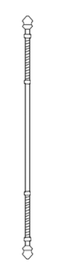 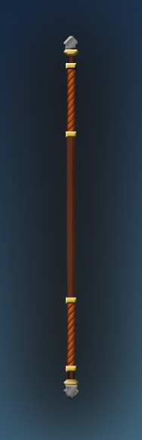

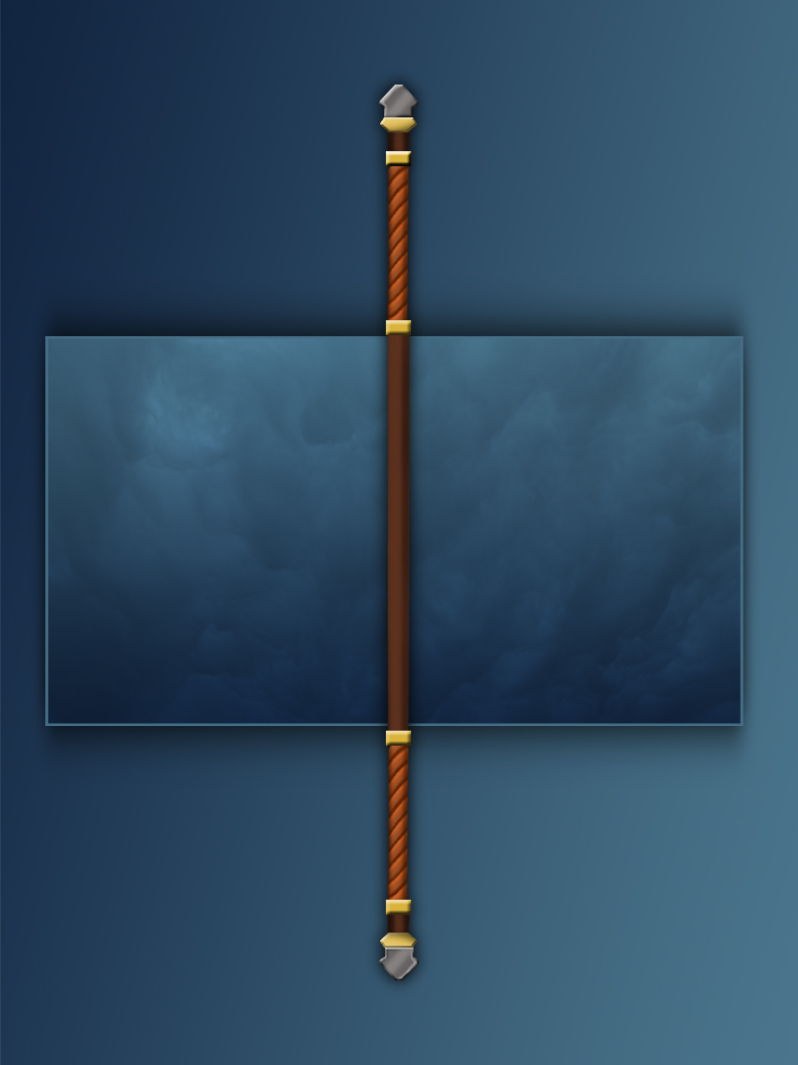

## Weapon Suite

For the final weapon suite, I placed the final weapon designs on my new background in the centre to make it stand out to the viewer. I also resized the dagger to make it have the right proportions compared to the others.

